Tower Defence: Alien Enigma

Detailed Project Design Document

Version 1.2

Keerthish Suresh

**Contents**

**1.** **Overview** 2

**2.** **Requirements** 3

**3.** **Game outline and Features** 5

**4.** **Initial Design Sketches** 6

**5.** **Modules of the Game** 8

**6.** **Pseudocode for the core game modules** 9

**6.1**. **Game Loop** 9

**6.2. WatchTower Management Module** 10

**6.3. Nemesis Management Module** 11

**7.** **Flow Chart** 12

**8.** **Class Diagram** 13

**9.** **System Architecture** 14

**10.** **Key Algorithms used** 14

**11.** **Design Decisions on error handling** 14

**12.** **Testing strategy** 15

**13.** **Ethical and Legal issues** 17

**14.** **Technical Requirements and Implementation Plan** 18

**15.** **Challenges and Future Scope** 19

**16.** **GitHub Repository and Conclusion** 19

## **Overview**

In this game of Tower Defence: Alien Enigma, the player must place their Watchtowers strategically to kill the enemies from reaching the target. By killing the enemies, player can earn resources that can be used to build and upgrade their towers. Each tower has its own unique range, strength, and attack style. Enemies have varying speed, health, and the reward capabilities. As the game goes on, the level gets more challenging with more waves and tougher enemies introduced to challenge the player.

**Justification:**

Tower Defence: Alien Enigma is chosen to challenge players with complicated improvised Watchtowers that require strategic thinking and problem-solving skills for better placements. The game integrates watchtower - defence mechanics, which adds complexity that makes it more than just a defence from the nemesis. My game selection will engage a broad audience.

This game will apply the fundamental computer science concepts such as pathfinding algorithms for nemesis moved and tower behaviour, game state management and user interaction design.

Additionally, the game will be developed using Object-Oriented Programming concepts such as modular coding, inheritance, polymorphism and encapsulation.

## **Requirements**

**Objectives**

- Develop a challenging and problem solving Tower Defence game with increasing difficulty and boosting the interest of the player.

- Implement OOP principles to ensure flexibility and efficiency.

- Create a visually engaging technophile with distinct nemeses and watchtower designs.

- Provide multiple difficulty levels, ranging from beginner to expert.

- Ensuring the game is up scalable and open to future enhancements.

**Problem statement**

Most of the Tower defence games mainly focus on killing the rivals, they lack in keeping the players engaged. However my game aims to solve these problems by introducing the below features,

1. Creating dynamic tower structures that can be paced at a different location and different direction.

2. Tactical watchtower placement, requiring players to think ahead.

3. Adaptive nemesis behaviour, ensuring progressing challenges.

4. An evolving system with increasing difficulty levels.

By combining these elements, the game provides a progressing challenge that keeps players involved.

**Target Audience**

- Casual, professional and committed gamers looking for immersive problem solving experiences.

- Technophiles who enjoy futuristic game aesthetics.

- Suitable for all age groups above 12, medium complexity will suite a broader audience.

- Entry level game developers can analyse and modify the game’s OOP structure.

## **Game outline and Features**

**Basic Features**

1. Tower Generation: Procedurally generated paths ensuring fresh challenges.

2. Watchtower: Players can deploy different types of watchtower to slow, damage, or slow nemeses.

3. Nemeses AI: Increasingly intelligent opponents adapt to player strategies.

4. Power-Ups: Items that enhance player movement or watchtower efficiency.

5. Heart points: Performance tracking for competition and progression.

6. Credit scores: Allow players to buy watchtowers to destroy the Nemesis.

**Game Progression**

- Level-based advancement: Players must clear multiple levels, each harder than the previous one.

- Upgrades system: Players can improve watchtowers and abilities over time by gaining more heart points.

- Storyline elements: Background knowledge connecting the towers to a larger skiffy narrative.

## **Initial Design Sketches**

**Design Sketches**

1. A blank play map

1. Initial screen with points and player life

‘

1. Route map for the enemies

## **Modules of the Game**

#### **GameManager Module**

**Purpose:** This module manages game variables and controls the game flow, level information, nemesis list, and money

**OOP Concepts Implemented:**

|  |  |
| --- | --- |
| **Concept** | **Implementation** |
| **Encapsulation** | **Nemesis, and WatchTower objects manage their own attributes, keeping their internal state hidden.** |
| **Inheritance** | **SniperWatchTower inherit from WatchTower, reusing base class logic.** |
| **Polymorphism** | **The game loop calls update() on all objects, regardless of type of the object.** |
| **Abstraction** | **The GameManager abstracts game logic, and update() abstracts individual object behaviour.** |

#### **Nemesis Module**

**Purpose:** This module generates new nemesis, manages their health, position, and movement towards the goal.

**OOP Concepts Implemented:**

|  |  |
| --- | --- |
| **Concept** | **Implementation** |
| **Encapsulation** | **Nemesis attributes like speed, health, and position are hidden and accessed only from methods.** |
| **Polymorphism** | **WatchTowers and game logic can interact with all nemesis uniformly, regardless of their specific type.** |
| **Abstraction** | **The GameManager class handles nemesis behaviour, hiding implementation details from the main game logic.** |

1. **Watchtower Module**

**Purpose:** This module allows the player to place the watchtowers in the play area for shooting the nemesis in the range, handles watchtower upgrade, and removing of watchtowers.

**OOP Concepts Implemented:**

|  |  |
| --- | --- |
| **Concept** | **Implementation** |
| **Encapsulation** | **Tower attributes (e.g., damage, range, attack speed) are hidden inside tower objects and accessed from methods.** |
| **Inheritance** | **Different types of towers (e.g., SniperTower, CannonTower) inherit from a base Tower class, reusing common functionality.** |

## **Pseudocode for the core game modules**

### **6.1**. **Game Loop**

// This module controls the complete game flow

CLASS GameLoop

INITIALIZE:

Create game window (screen)

Set clock for time tracking

Create empty lists for nemesis and watchtowers

Load background image, sound effects, and other resources

Initialize GameManager (level, map, and game data)

FUNCTION start_game()

WHILE player_health > 0 AND nemesis_remaining()

CALL process_user_input()

CALL update_game_objects()

CALL render_graphics()

WAIT (frame_time)

END WHILE

IF player_health <= 0

DISPLAY "Game Over!"

ELSE

DISPLAY "You Win!"

FUNCTION process_user_input()

IF user_clicks_on_watchtower

CALL place_watchtower_at(mouse_position)

IF user_clicks_upgrade

CALL upgrade_watchtower(selected_watchtower)

IF player_clicks_quit

DISPLAY "Game Over!"

FUNCTION update_game_objects()

FOR each watchtower IN game_watchtowers

CALL watchtower.attack()

FOR each nemesis IN nemesis_list

CALL nemesis.move()

CALL check_collisions()

FUNCTION check_collisions()

FOR each watchtower:

Check if it is targeting any nemesis

if yes, update damage to the nemesis and play shooting sound

FUNCTION render_graphics()

DRAW game_grid

DRAW watchtowers

DRAW nemesis

DISPLAY UI elements

### **6.2. WatchTower Management Module**

// This module manages the behaviour of the WatchTower

CLASS WatchTower

INITIALIZE:

set upgrade_level, range, cooldown, last_shot, target, and position (tile_x, tile_y)

set initial watchtower and animation for the watchtower

create range circle for visual indication

FUNCTION Attack(nemesis)

IF nemesis WITHIN range:

nemesis.TakeDamage(damage)

END FUNCTION

END CLASS

FUNCTION PlaceWatchTower(type, position)

IF player has enough resources:

CREATE new watchtower of type at position

DEDUCT watchtower cost from player resources

ELSE:

DISPLAY "Not enough resources"

END IF

END FUNCTION

FUNCTION UpgradeWatchTower(watchtower)

IF player has enough resources:

watchtower.IncreaseDamage()

watchtower.IncreaseRange()

DEDUCT upgrade cost

ELSE:

DISPLAY "Not enough resources"

END IF

END FUNCTION

### **6.3. Nemesis Management Module**

// This module manages the behaviour of the Nemesis

CLASS Nemesis

INITIALIZE:

Set health, position, speed based on input

FUNCTION Move()

UPDATE position towards goal

END FUNCTION

FUNCTION TakeDamage(amount)

health = health - amount

IF health <= 0:

CALL OnDeath()

END FUNCTION

FUNCTION OnDeath()

INCREASE player resources by reward_value

REMOVE nemesis from game

END FUNCTION

END CLASS

FUNCTION SpawnNemesis()

IF spawn timer reached:

CREATE new Nemesis at starting point

ADD to nemesis list

RESET spawn timer

END FUNCTION

FUNCTION UpdateNemesis()

FOR EACH nemesis in nemesis list:

nemesis.Move()

IF nemesis REACHED goal:

DECREASE player health

REMOVE nemesis

END FUNCTION

## **Flow Chart**

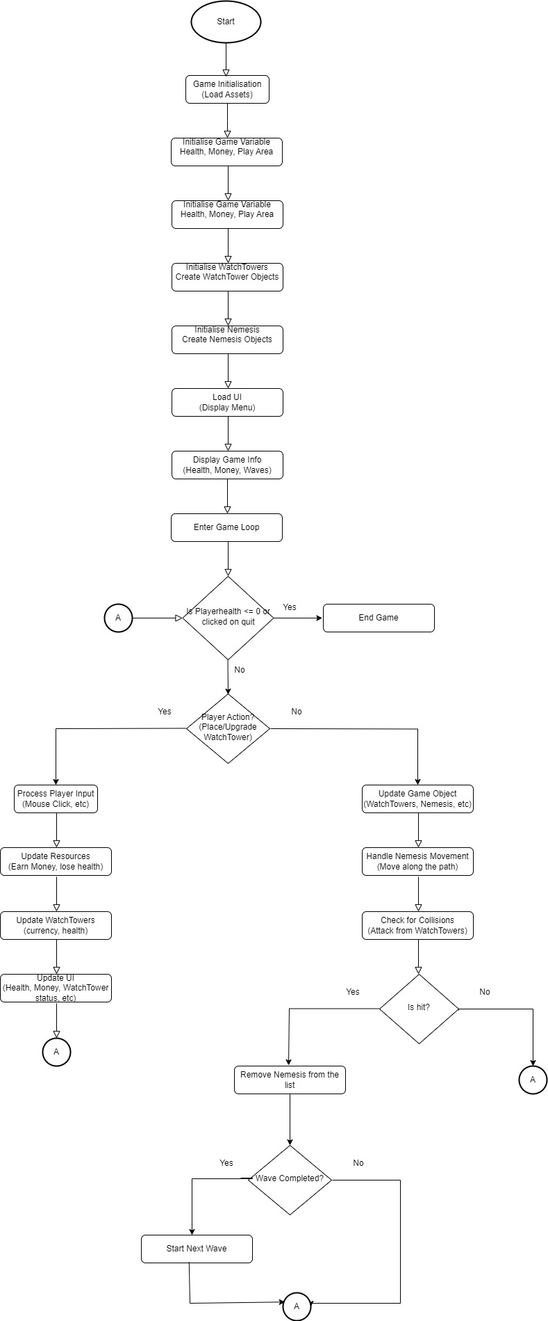

## **Class Diagram**

## **System Architecture**

Below is the System Architecture connecting all modules and their interactions

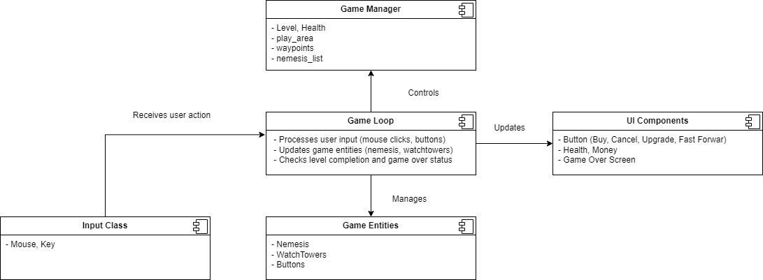

## **Key Algorithms used**

Alien Enigma is implemented using various algorithm. Below table highlights the key algorithms used in the game:

|  |  |  |
| --- | --- | --- |
| **Where Used** | **Algorithm Used** | **Purpose** |
| **Nemesis Pathfinding** | Pathfinding Navigation | Moves nemesis from the initial point towards goal |
| **WatchTower Targeting** | Nearest Enemy Targeting | Used for finding and attacking the closest nemesis in the range |
| **Nemesis Spawning** | Wave-Based Spawning | Generates nemesis dynamically based on level data |
| **Level Progression** | Enemy Kill Count Check | Determines when the level is complete |

## **Design Decisions on error handling**

**Some of the error handling strategies that will be implemented are as follows:**

* Designing the game with clear and informative error messages for the player
* Use of structured error handling (e.g., try-catch blocks) to prevent game crashes
* Validating inputs and game state before processing actions to prevent invalid operations.

1. **Input Validation**

This is to ensure the player input (such as watchtower placement, selecting enemies, and menu interactions) is validated before it is processed. Invalid inputs are ignored without causing the game to crash.

For example, if a player tries to place a tower in an invalid position (e.g., outside the grid or overlapping with another tower), the game will not accept the input prompting the player to try again and if a player enters an invalid key press or unresponsive input, the game will ignore the input.

1. **Boundary and Edge Case Handling**

This is to carefully handle edge cases where the game’s state might be in a rare or unexpected situation (e.g., resources running out, health dropping to zero, or having no more waves).

In these scenarios the game never crashes and the handled gracefully by displaying a game-over screen when health reaches zero and an alert when the player runs out of resources or encounters an invalid action.

1. **Game State and Resource Integrity**

This is to ensure that game resources, health, and other critical game variables (such as nemesis spawn counters) are never in an invalid state (e.g., negative health, impossible wave number).

In order to prevent this, these games variables are always set to a known to start with.

## **Testing strategy**

Below testing strategies is used in the game development. Where possible the testing is automated, if not they are manual done.

* Unit testing individual game components to ensure correctness.
* Integration tests to verify that different game modules interact correctly.
* Perform UI testing to ensure proper visual feedback and interaction.
* Conducting end to end testing to ensure the overall gameplay experience is enjoyable and bug-free.
  1. **Unit Testing**

This will be an automated test where the module is broken down into smaller units (e.g., Nemesis, WatchTower, GameState) and are verified for their correctness in isolation.

This testing will be done using mock data and compared with the expected behaviours.

**An example of the Unit Test:**

def test_watchtower_initialization(self):

"""Test if the watchtower initializes correctly."""

self.assertEqual(self.watchtower.x, self.watchtower_x)

self.assertEqual(self.watchtower.y, self.watchtower_y)

self.assertEqual(self.watchtower.range, self.watchtower_range)

self.assertEqual(self.watchtower.damage, self.watchtower_damage)

self.assertIsNone(self.watchtower.target)

def test_attack_nemesis(self):

"""Test if the watchtower deals damage to a nemesis."""

initial_health = self.nemesis_in_range.health

self.watchtower.attack(self.nemesis_in_range)

self.assertEqual(self.nemesis_in_range.health, initial_health - self.watchtower_damage)

* 1. **Integration Testing**

This automated testing is to validate how different game modules work together. For example, test if a nemesis moves correctly while watchtowers are firing and if the resources are correctly deducted when a watchtower is upgraded.

**Example Integration Test**:

def setUp(self):

"""Set up a watchtower and a nemesis for integration testing."""

# Watchtower at (100,100) with range 75 and damage 10

self.watchtower = Watchtower(100, 100, 75, 10)

# Nemesis with 10 health

self.nemesis = Nemesis(120, 120, c.NEMESIS_SPEED, 10)

def test_nemesis_detection_and_attack(self):

"""Test if a watchtower detects and attacks a nemesis correctly.

""" # Step 1: Check if the watchtower detects the nemesis self.assertTrue(self.watchtower.is_nemesis_in_range(self.nemesis))

# Step 2: Attack the nemesis attack = 10 damage

self.watchtower.attack(self.nemesis)

# Step 3: Check if the nemesis's health reached zero self.assertEqual(self.nemesis.health, 0)

# Step 4: Verify that the nemesis is eliminated from the game self.assertTrue(self.nemesis.is_dead())

* 1. **UI Testing**

This will be a manual testing to ensure the game’s interface is user-friendly and displays accurate information, such as health, resources, and current wave.

* 1. **End-to-End Testing**

This testing is to simulate a complete game session from start to finish to ensure that all game features and logic work as expected. This testing is conducted manually.

## **Ethical and Legal issues**

Below are some of the ethical issues considered:

* Alien Engima does not use any excessive violence, or inappropriate themes. The nemesis are **fictional, non-human, or robotic** to avoid real-world implications.
* This game always has an end and will not promote unhealthy gaming habits.
* Game difficulty is **balanced** and does not unfairly punish players.

Below are some of the legal issues considered:

* All **art work, sounds, and code** copied from other sources will be follow the license agreement and will be appropriately acknowledged.

## **Technical Requirements and Implementation Plan**

**Software Requirements**

- Programming Language:

* Python v3.12.0, pygame v2.5.2, unittest v3.13.2
* Visual Studio Code

- Version Control:

* GitHub for source control
* Git Bash and Source tree for committing the code and pulling from the source control.

- Graphics & Assets:

* Custom-designed images for gameplay.

- Documentation and designing/sketching:

* Microsoft Word for documentation
* Draw.io for UML Designs

**Hardware Requirements**

- System Requirements: A PC with any operating system.

- Storage: At least 500MB for assets and game files.

**Implementation Plan**

1. Stage 1 (Week 1-2): Research & Initial Game Design Sketches.

Week 3 - Deliverable 1 – Project proposal and equipment specification.

2. Stage 2 (Week 3-4): Develop the Game Engine and Player Movement.

3. Stage 3 (Week 5-6): Implement WatchTower and Nemesis AI Mechanics.

Week 5 - Deliverable 2 – Detailed project design document.

4. Stage 4 (Week 7-8): Refine Game Levels and Introduce Power-Ups.

Week 7 - Deliverable 3 – Initial Prototype / Development milestone.

5. Stage 5 (Week 9-10): Testing, Debugging, and Performance Optimization.

Week 9 - Deliverable 4 – Intermediate project update.

Week 11 – Final Delivery – Final Project Submission.

## **Challenges and Future Scope**

**Potential Challenges**

- Balancing difficulty levels, to ensure impartiality and engagement.

- Optimizing AI behaviour for smooth performance and pragmatism.

- Using high quality 3D images without affecting game performance.

**Scope for enhancement:**

- Enhancement to include multiplayer features.

- Additional game modes, like time-based challenges and persistence modes.

## **GitHub Repository and Conclusion**

For ongoing development, access the source code and latest updates here:

GitHub Repository: Alien Enigma https://github.com/skeerthish/AlienEnigma

**Conclusion**

Tower Defence: The Alien Enigma is designed to push players’ strategic thinking while providing an immersive experience. With structured OOP design and sensibly created game mechanics, this game will provide both technical and entertainment value.

This document serves as a broad project proposal and requirements specification, guiding the structured development of the game. Additional enhancements will be made based on game development, iterative testing and feedback.